First of all, my program is design from a socket call: non-blocking socket. In normal recvfrom, the program will block there until it get a packet, for non-blocking socket, the recvfrom will not block. If I can not receive anything, the function will just return [-1].

The size of data in a single packet is 1000 byte, with the header, the size of will be about 1070 byte.

Below are the Finite state machine diagrams:

In the client part: After the client start, sent [SYN] to server. if receive [ACK] from server, go next wait for user input, otherwise sent [SYN]again. After user input comment, check this is a get or get-post. If this is a get, sent get_ request Packet to server and wait for server sent data packet to client. Wait until all the data packet done. After the file done, write the file and go back to the user input part. If the comment is get-post, sent get requires to server and then also sent data packet to server, the client will wait until two part are done, then go back to the user input mode. If user input: disconnect, client will sent [Fin]to server and wait for ACK, if no ACK, sent Fin again, if get ACK, close the client

For the Server part: The server will keep running [receive], and do some action depends on what kind of packet it receives. If get a SYN from client, add new client in my client array, if get a get-request, sent data file to client, if get a data packet, make space for the up-load file. If get a Fin, sent ACK back to client.

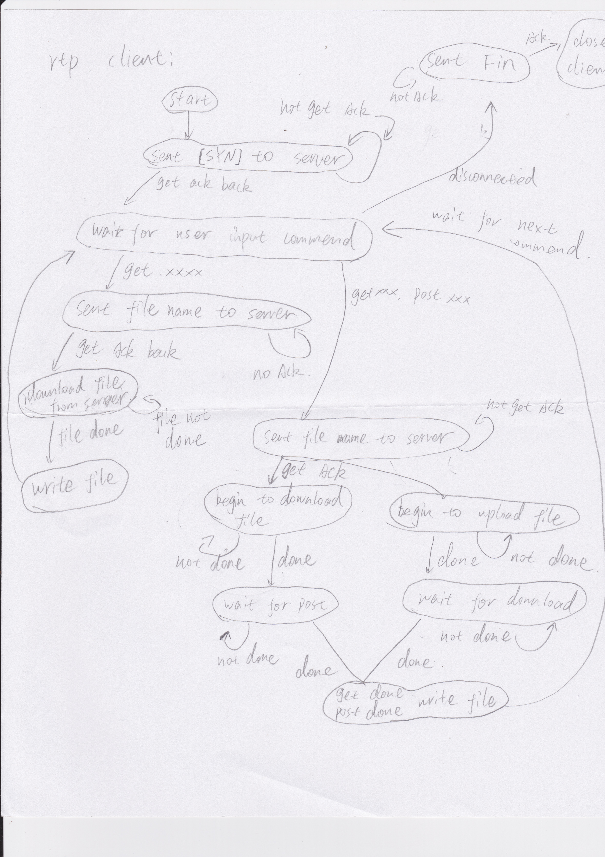

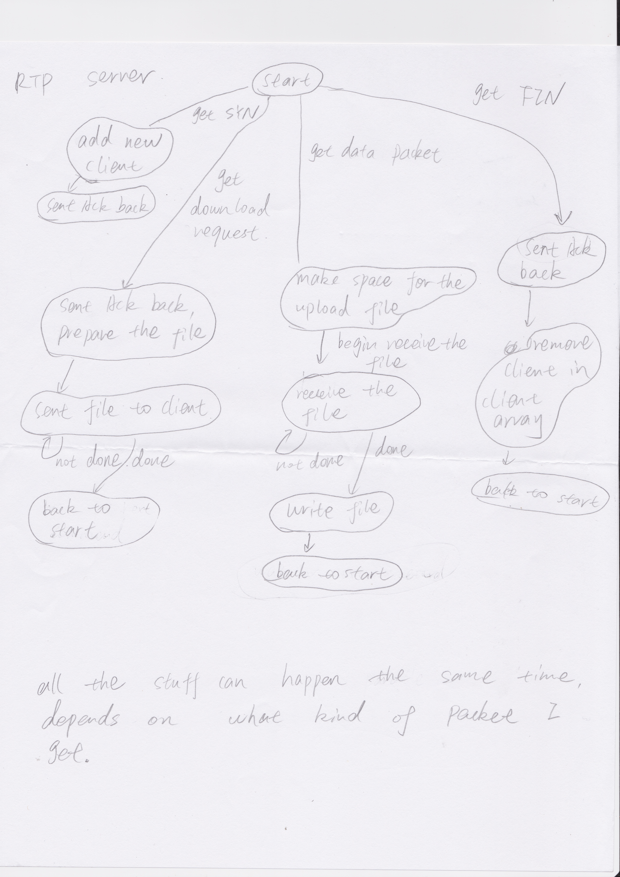

In my packet header, I have checksum, sequence number, packet type, payload_length, window_size and clntaddr.

For packet type: I have:

DATA: DATA packet,

LAST_DATA: my last packet of my file

ACK: my [ACK]

LAST_ACK: the ack for my last file

SYN: begin the connection with server

GETrequest: sent from client to server, tell server the file client want

Request_ACK: the [ACK] for my GETrequest.

FIN: tell server the client want to disconnect.

functions it exports to the application layer:

bindd: bind server to the port

setup_socket_client: setup the socket in client, this function will handle the 2 way- hand shake part for the client.

Accept: function for server, to accept the connection from client.

Send: sent packet, pass in the file buffer, file size, which packet to sent and the window size.

Recvv: recv packet, this function will take care reorder/dup packet/ packet lose all kind of issue and return to the application correct packet.

Function inside RTP:

Checksum: calculate the checksum for the packet, sum all the char value together and get a number. Will return the checksum

Packetize: make the file buffer in to packet, the file buffer size will decide how many packet we will get. This function will return the packet array.

0: How can I handle multiple client:

I have a two dimensional array call CLIENTARRAY in my server, every time I get a new client, I will add new element in to the CLIENTARRAY. For Each client, it has:

DATAarray: the data I receive from client.

Portnumber: the port number of my client.

Clntaddr: the client information

sent_window_Size: window size of my client

file_get: the file I receive from that client.

start_time: the value for timeout function.

Sentnumber: the sequence number I need to sent to this client.

Sentamount: how many packet I should to sent to this client.

expect_number: the next packet I suppose to get from this client

every time after my server receive window is full(or timeout), I will demultiplex packet to each client.

1: How does RTP perform connection establishment and connection termination?

First we need to make sure the server is running. Everytime when we start a new client, the client will sent [SYN] to the server, then the server will sent [ACK] back to my client, then my client will sent[ACK] back to server. After the ACK receive by my server, the connection is established and can begin transfer file. For the termination, client will sent[FIN] to server and wait for server sent[ACK] back to client, then the connection is done

2: How does RTP perform window-based flow control?

Everytime when the connection begin, the client and server will let each other know the window size of each side. When we send the file to each other, the send function will not send more packet then the window size.

3: How does RTP perform congestion control?

When the connection start, I will only sent 1 packet at a time, if I can get my [ACK] as expect, I will increase my send size by 1, and stop increase the send-size after reach the allowed window size. If packet lose, I will drop the send size to 1 and start increase again.

4: How does RTP detect and deal with duplicate packets? How does RTP detect and deal with reordered packets? (answer two question together)

First, I give all packet a sequence number.

in my receiver side, I have a variable name: expected_value. This tells my receiver what is the correct sequence number I should get for next packet. For example, if I already get packet: 1, 2, 3; I expecting packet number 4. If I now get packet number 4, I will send [ACK-4] back to my sender, if I get any other packet, like packet 3 again or packet 5(reorder) I will just ignore those packet. On my sender side, I will send packet according the largest [ACK] number I get.

5: How does RTP detect and deal with corrupted packets?

Use checksum.

When I packetize my file buffer in to packet, I calculate the checksum of each packet and include in my packet header. After packet arrive the receiver, I calculate the checksum according to the data I get and compare two checksum value, if two value is not the same, I know my packet is corrupted and just ignore that packet.

6: How does RTP detect and deal with lost packets?

If I can not get [ACK] in 0.5 second, I will timeout and resend the packet.

7: How does RTP (de)multiplex data to different RTP connections at the same host?

After I receive packet, I will separate them according to their port number: clntaddr.sin_port.

8: How does RTP support bidirectional data transfers?

Just add send function in my client and sent data packet to server, nothing special.

9: How does RTP provide bytestream semantics?

I break the file in to data packet, each packet has 1000 byte of data, the recv function will receive those data byte and finally combined them all together. So this is bytestream semantics.

10: Are there any special values or parameters in your design (such as a minimum packet

size)?

Expected_Value: this is the packet number I am expecting, ignore all other packet number.